Task 1:

OUTPUT:

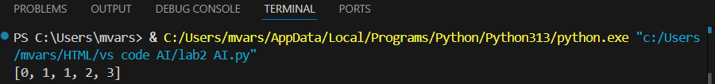

Task 2:

OUTPUT:

Task 3:

OUTPUT:



Task 4:

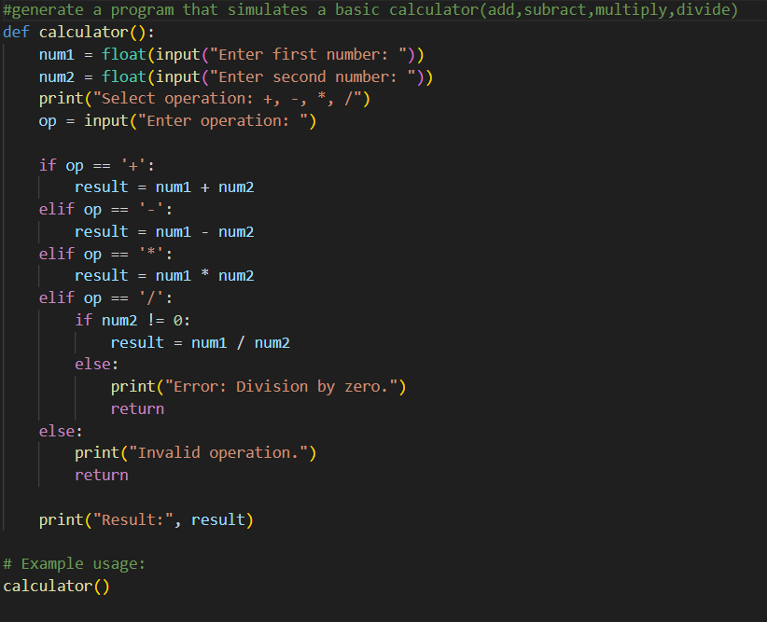

OUTPUT:

Task 5:

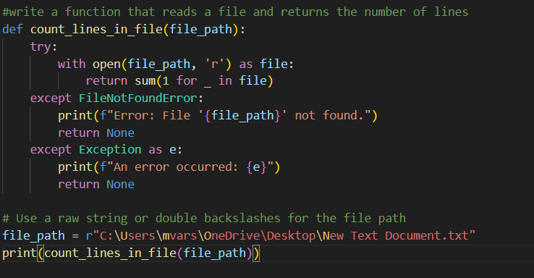

OUTPUT:

